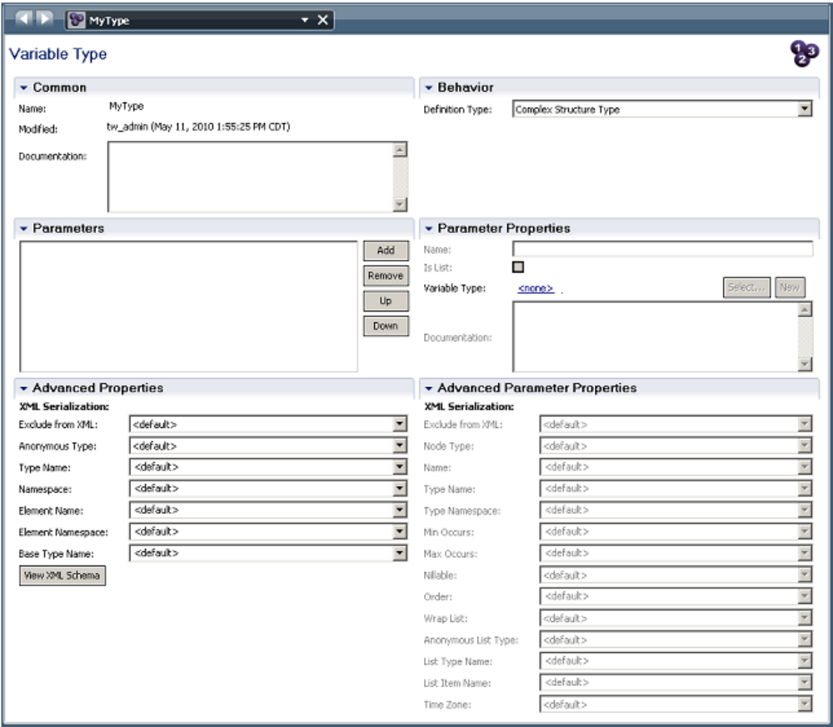
In the Behavior section of the data type editor, there are two choices:
在数据类型编辑器的《行为》区域，有两个选择

• Complex Structure Type
组合结构类型

• Simple Type
简单类型

When a complex type variable is created, it must be initialized before it can be used. This can be done through JavaScript with the code:
当创建一个组合类型变量的时候，必须初始化后才能使用该变量。这个动作可以通过javascript代码来实现。

tw.local.myVariable = new tw.object.ComplexType();

A similar story is also true for data of type list:
同样适用于是List 类型的数据.
tw.local.myListOfStrings = new tw.object.listOf.String();

Simple Types
简单类型

The Simple Type allows us to place constraints on certain simple data types.
简单类型变量允许我们对简单数据类型加些限制。

Simple type – String
简单类型-字符串类型
Here we can place length restrictions on the string. This includes either a fixed length or a
minimum/maximum length.
这里我们能够《设置》字符串的长度，包括一个固定的长度或者一个最小/最大的长度.

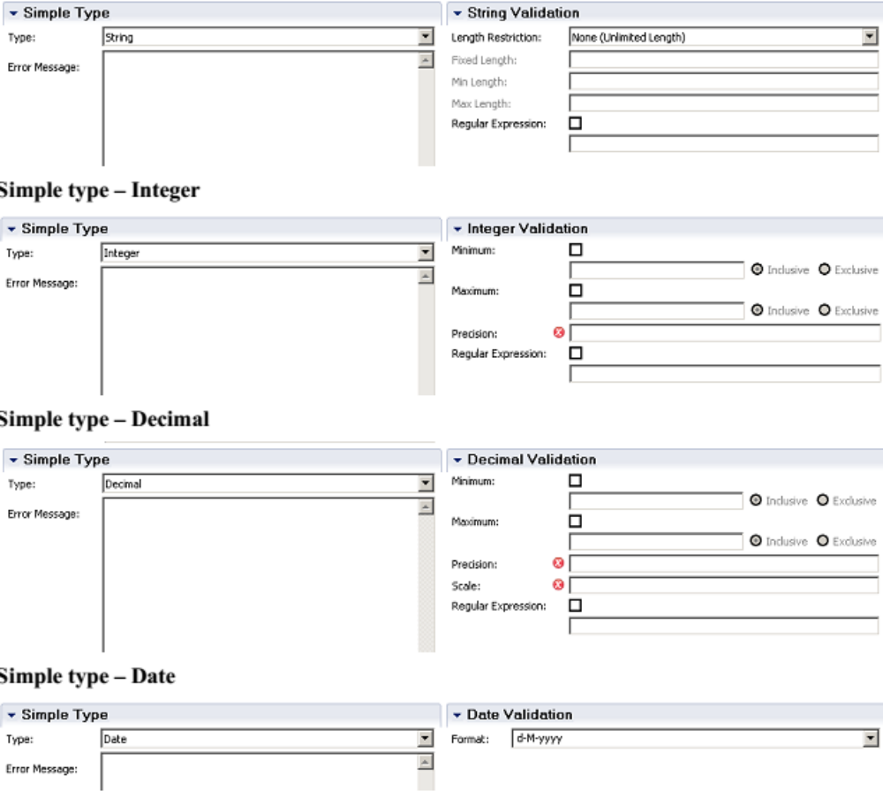
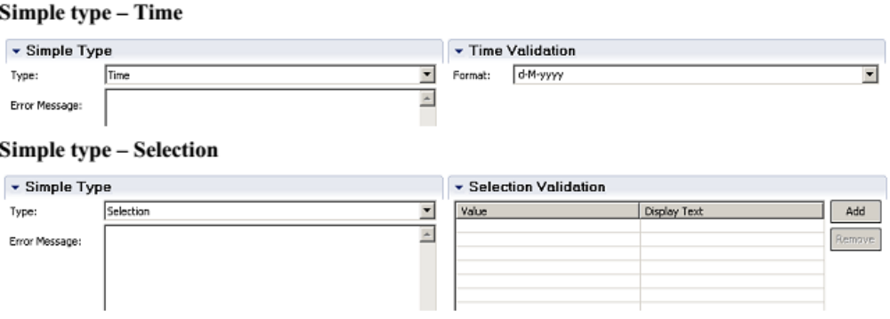

Business Object Types
业务对象类型
A Business Object is commonly used to describe a series of attributes that apply to a concept being
worked upon in a process. Consider the concept of a "Customer". A Customer has many attributes
including name, address, payment info, purchase historyand perhaps much more. We can define
the data type known as Customer by creating a new data type within IBPM PD.
一个业务对象常常用于描述一系列作用于流程的属性，假设 一个 "customer"的内容,
一个顾客有多个属性，包含名字，地址，付款信息，购买记录 或者更多。
我们能够通过IBPM PD 创建一个新的数据类型定义这些数据为顾客 类型。

A new data type can be created from the Data entry in the list and selecting Business Object
可以通过Data entry 里的列表中选择Business Object 来创建新的数据类型.

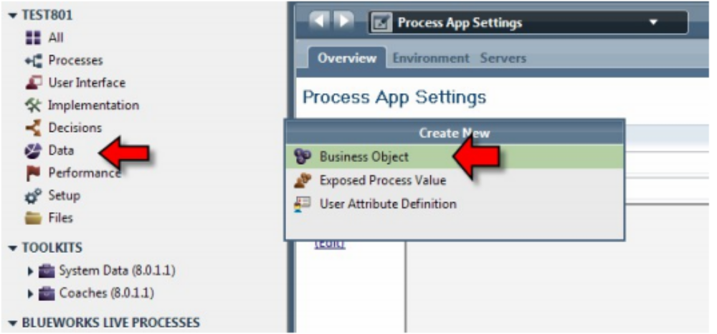

Once selected, a dialog window appears asking us to name the new data type we are creating. In
this example, we have called our new data type "Customer":
选择后，一个对话框要求我们输入新创建数据类型的名字，在这个例子里，我们命名新的数据类型为 "Customer"

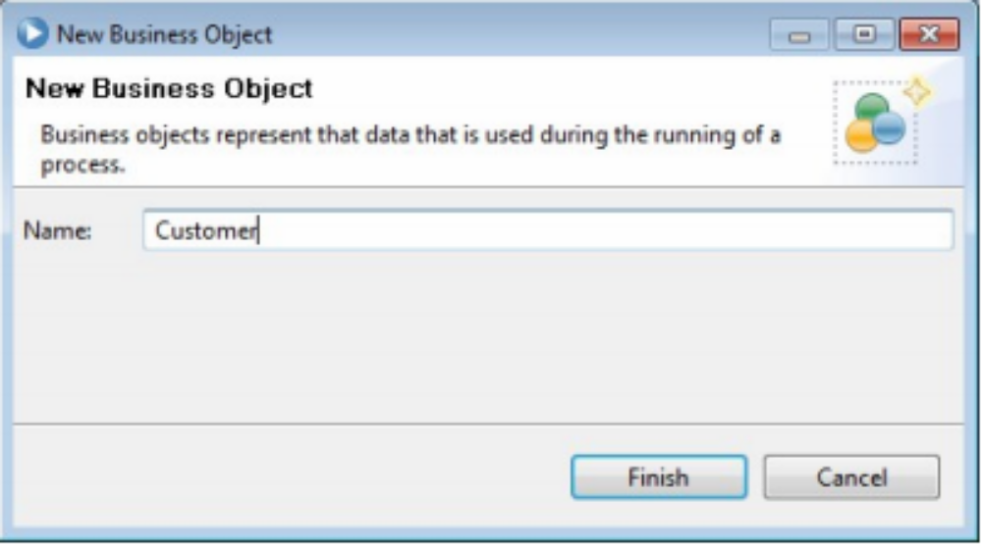

Once the data type has been created, the fields of the new structure may be defined.
IBPM calls what I call field"Parameters". Some products call such data entries "fields", some call
them "attributes", others call them "properties" … so why should we not allow IBPM to call them
"Parameters".
一旦数据类型被创建后,新结构的属性字段能够去定义, 比较有趣的是
IBPM 称这些为 参数,一些其他厂商的产品称这些数据实体为“字段", 一些称为 "属性", 其他的称为"属性”？
所以,为什么IBPM不能称他们为 “Parameter".

An arbitrary number of parameters can be added to the structure by pressing the "Add" button.
点击 "Add" 按钮能够添加任意数量的参数到结构里。

When a parameter is added, its name and data type can be defined. The data type of a parameter
can itself be a complex type allowing for a tree like structure to be created. The parameter can also
be flagged as a "List" allowing the one parameter to hold zero or more values.
添加一个参数的时候，能够去定义它的名字和数据类型， 参数的数据类型能够是一个组合类型，能够创建一个树形结构，参数同样能够标示为 能够持有0个或多个数据的List 。

